User Manual
How to share a file



How to Securely Share a File with SpecterX
SpecterX makes secure file sharing simple and seamless across all your favorite tools - including Outlook, Gmail, and the SpecterX Web Platform.

This guide explains how to install SpecterX, protect your emails, and securely share sensitive files.

Outlook
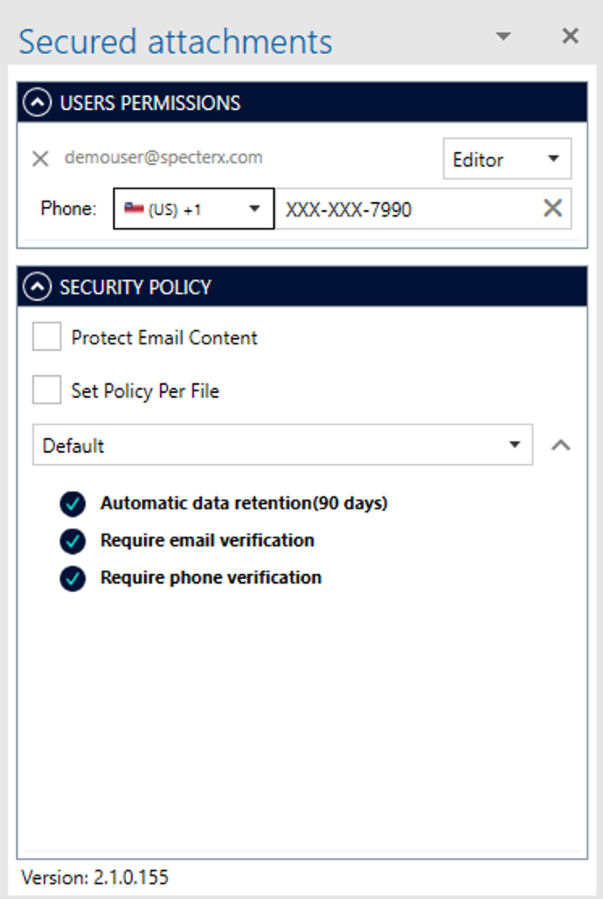

SpecterX Web Platform
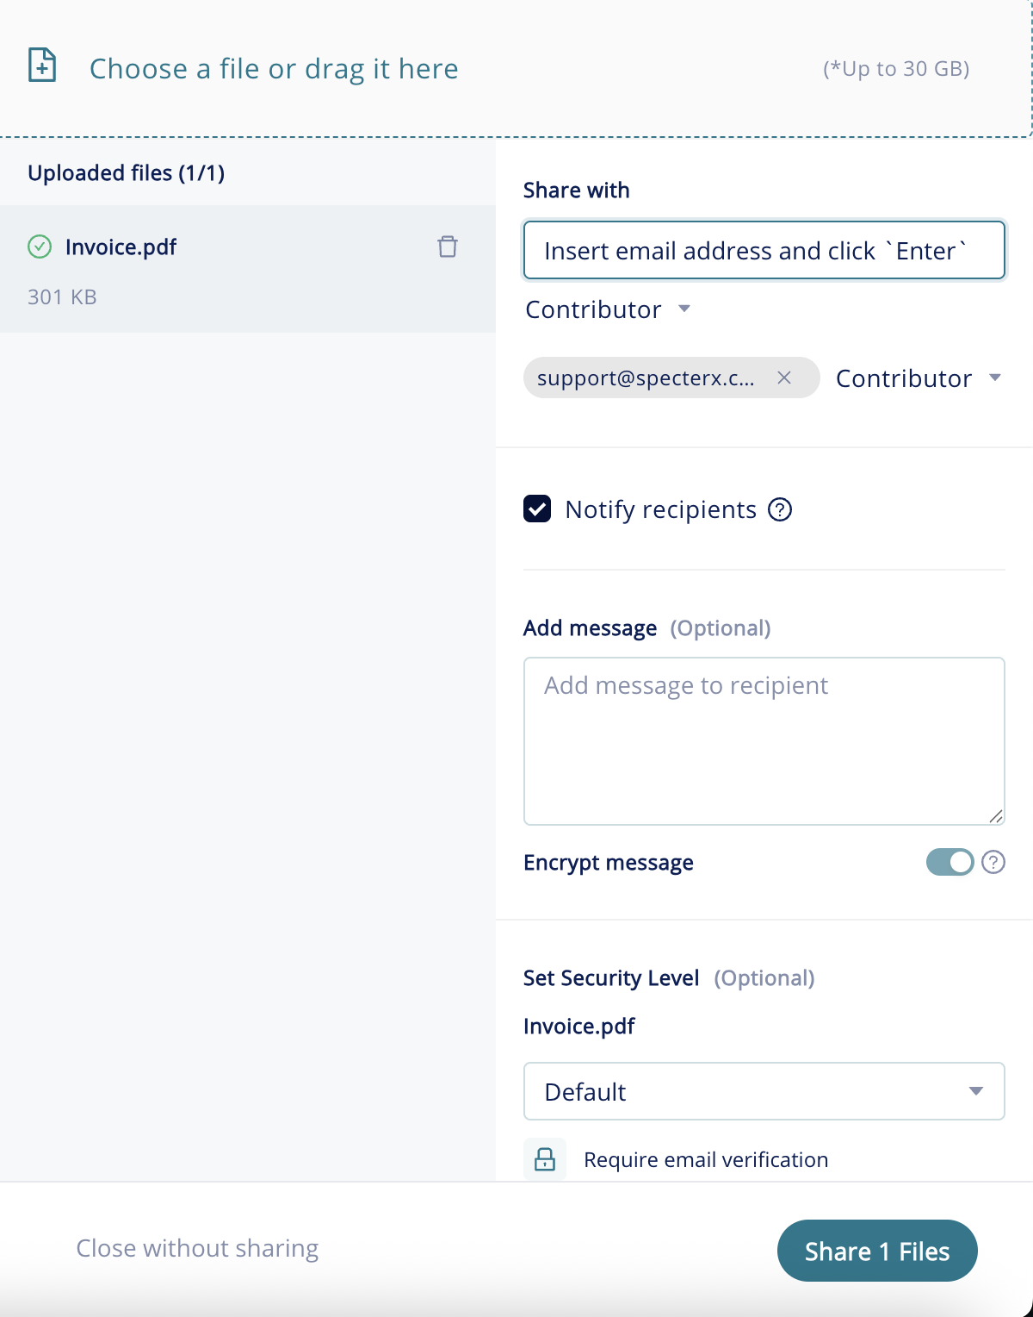

Gmail
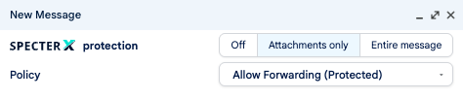

Sharing a File Securely from Outlook

Install the SpecterX Outlook Add-in
If your system administrator hasn’t installed the Add-in for you, follow these steps:
- Download the SpecterX Outlook Add-in (MSI file) from your administrator or the approved company source.
- Double-click the installer and follow the on-screen instructions.
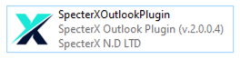

Once installed, you’ll notice a new icon in Outlook’s top menu bar:
SpecterX – Enable Protection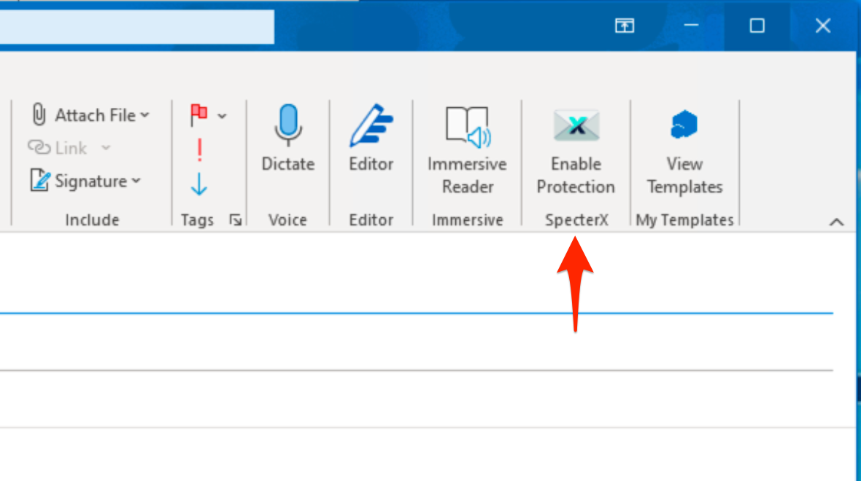

Protecting an Email
Now that the Add-in is installed, you can share files securely.
- Open Outlook and create a new email.
- Add your recipients in the To, CC, or BCC fields.
- Attach the files you wish to share.
- Click Enable Protection from the top menu bar.
The SpecterX panel will open on the right-hand side of your window.
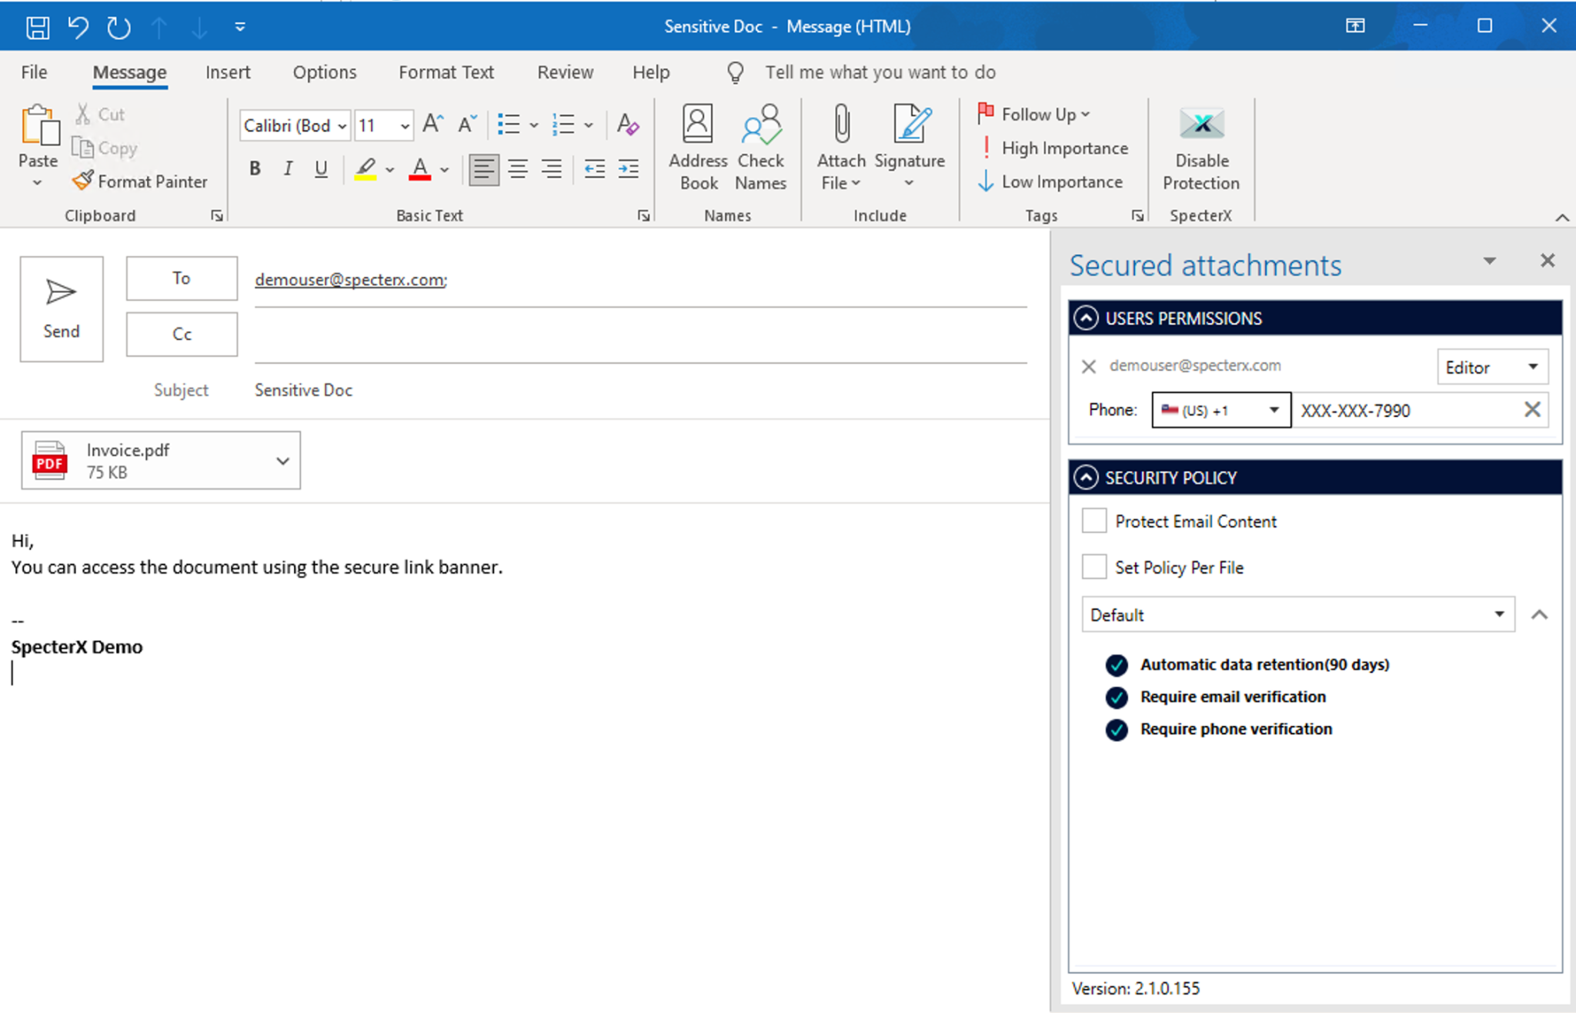

- For each recipient, choose their permission level
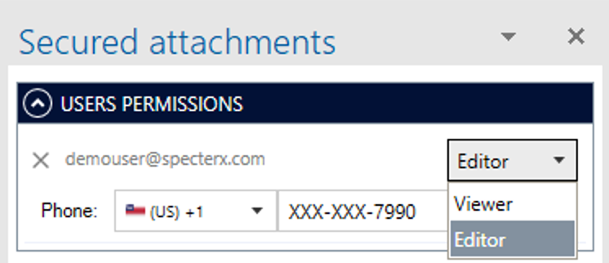

- To also secure the email body and subject line, check Protect Email Content.
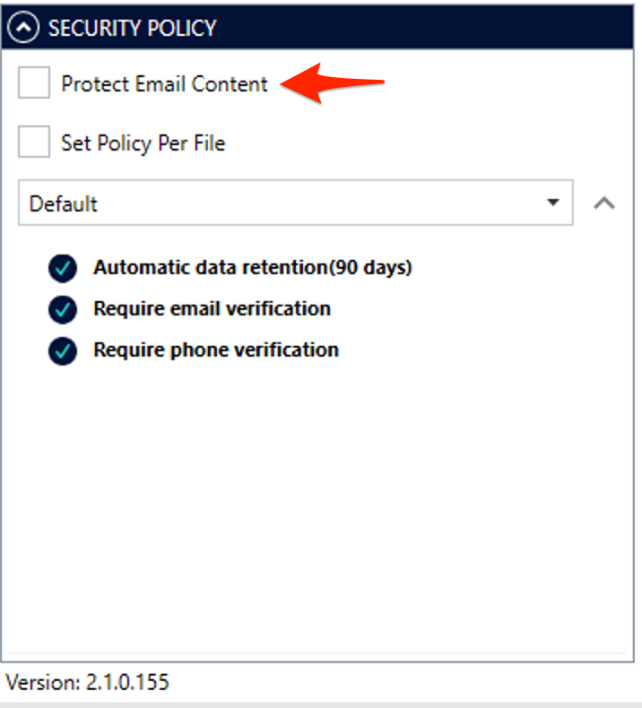

- Select a security policy for your attachments:
  - Choose from the dropdown menu
  - Or, keep the Default policy assigned by your system administrator.
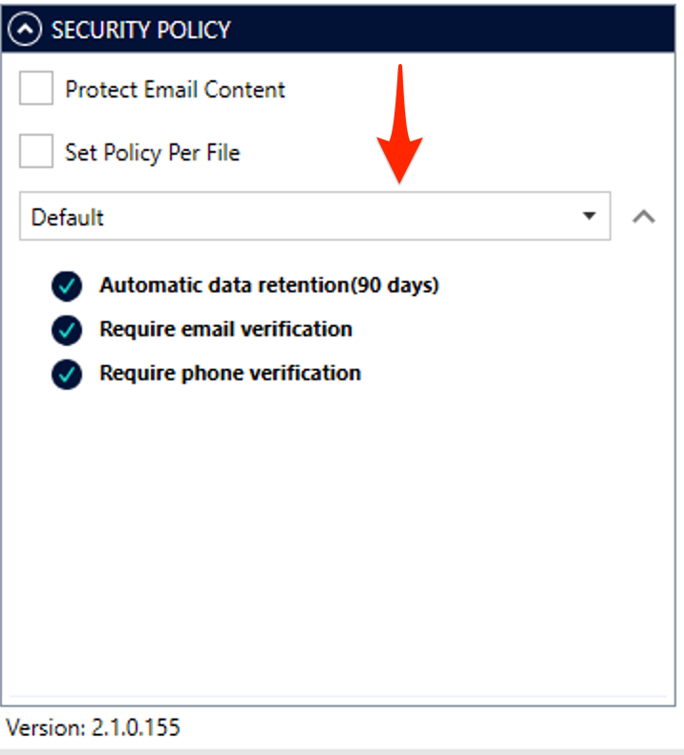

If the chosen policy requires Phone Verification, you’ll be prompted to enter the recipient’s phone number.
This ensures that only verified users can access your secured files.
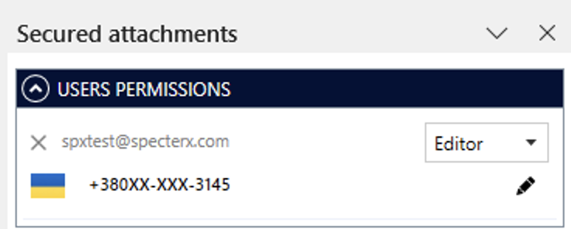

If the chosen policy requires Personal Secret Verification (required for getting access to the file) or File Encryption by Password (required for opening the file after download), you’ll be prompted to enter the recipient’s password.
This ensures that only verified users can access your secured files.

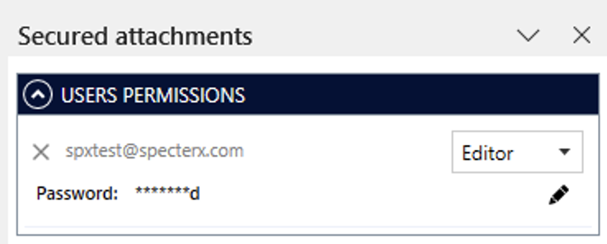
That’s it! Your email and attachments are now fully protected with SpecterX.

Sharing a File Securely from Gmail

Protecting an Email
Once the SpecterX Gmail Extension is installed by your administrator, you’re ready to share a secure file.
- Click Compose to create a new email.
- At the top of the New Message window, you’ll see a new section: SpecterX - Protection.
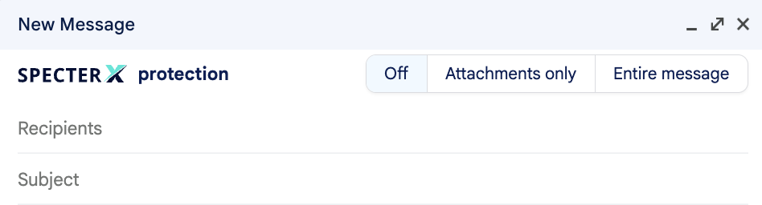
- Choose what to protect: Attachments only or Entire message (i.e. both Message and Attachments).
- Add your recipients in the To, CC, and BCC fields and attach the files you want to share as you normally would.

- Select the security policy that best fits your data sensitivity.
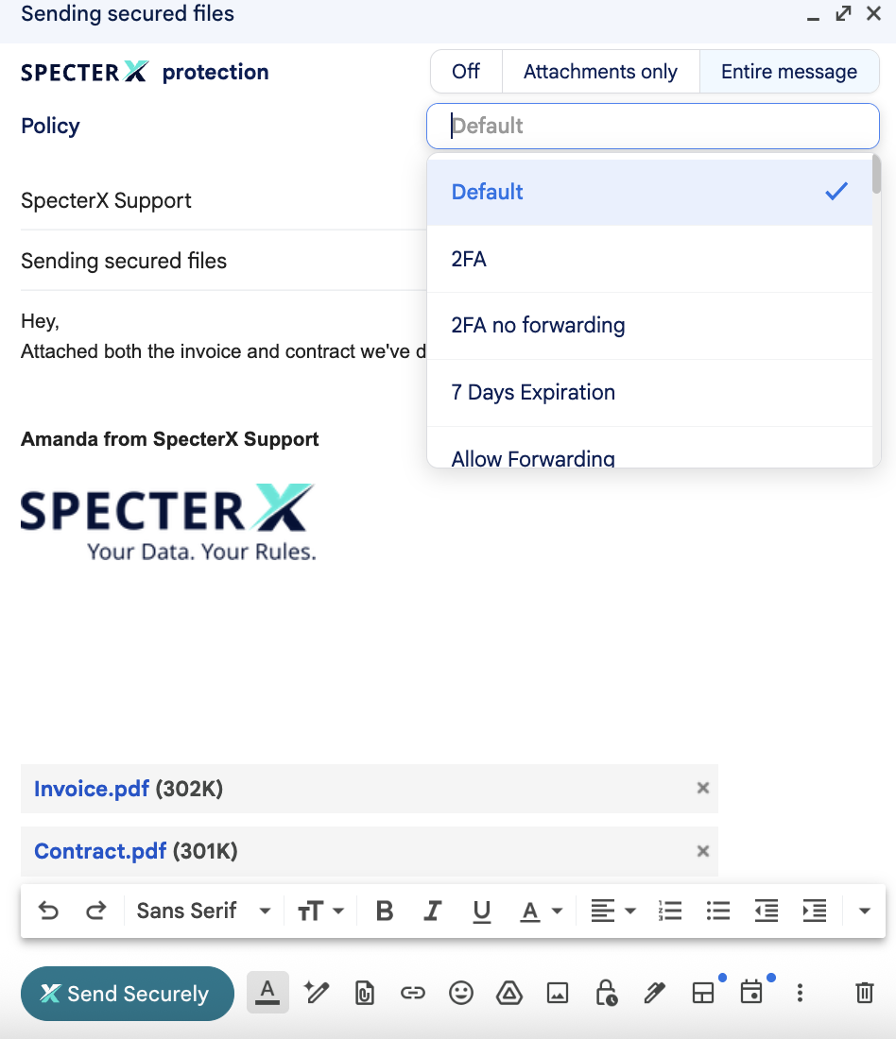

- Assign recipient permissions for each contact
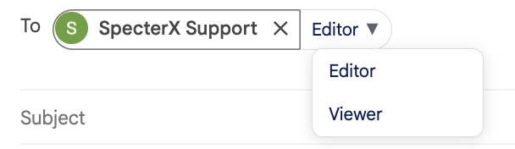

That’s it! Your email and attachments are now fully protected with SpecterX.

Sharing files securely from SpecterX Web Platform

Logging in to the SpecterX web platform
- Open your browser and visit your organization’s SpecterX portal:
https://your-org.specterx.com
- Log in using your corporate identity credentials.

Sharing a file
- Click Share Files on the right-hand side of the dashboard.
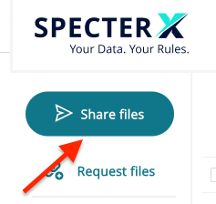

- Drag your file(s) or folder(s) into the gray upload box, or click to select them manually.
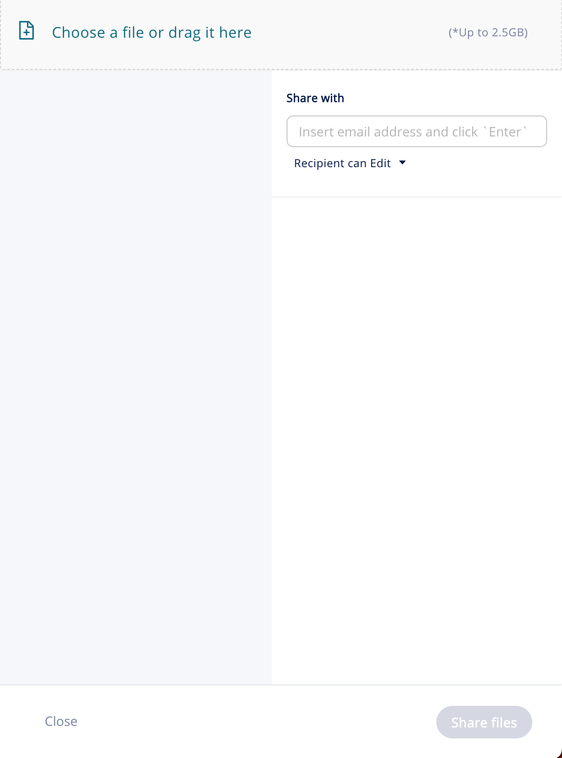
- Wait for the upload to complete — once the progress bar turns green and reaches 100%, your files are securely stored.

- Under Share With, enter recipient email addresses and click Add (or press Enter).
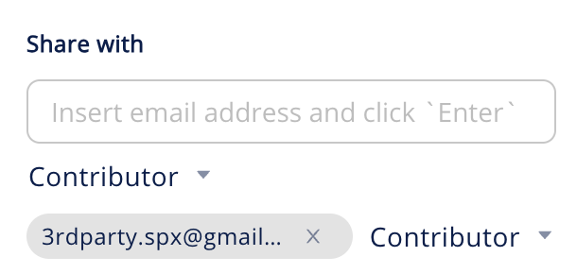

- Set recipient permissions from the Contributor dropdown menu and choose whether recipients will receive an email notification from SpecterX (by checkbox “Notify recipients”)
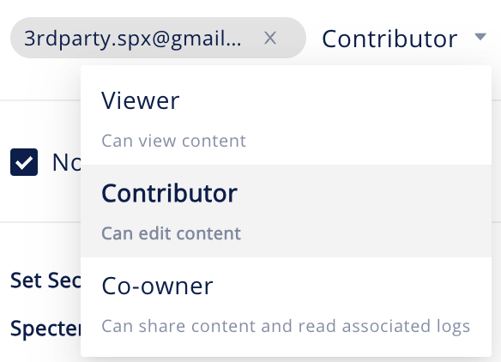

- Adjust the security policy for each file as needed.
You can also apply a policy to all uploaded files by clicking Set for All.
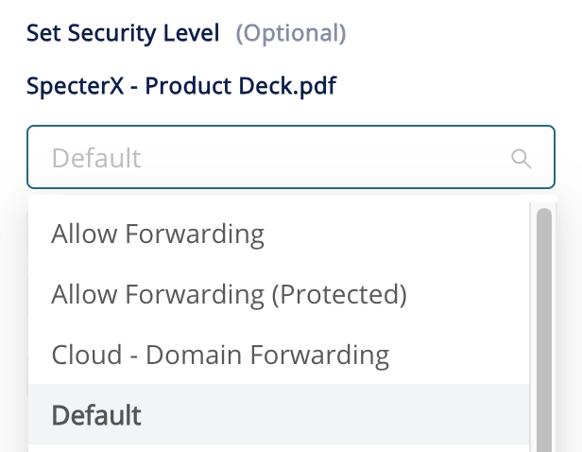
- When ready, click Share Files at the bottom-right corner.


Success! Your files are now shared securely.
You can also copy the sharing link using Copy to Clipboard to include it in emails or instant messages.

If at any point you need assistance, our team is always glad to help.
Find us at: support@specterx.com

